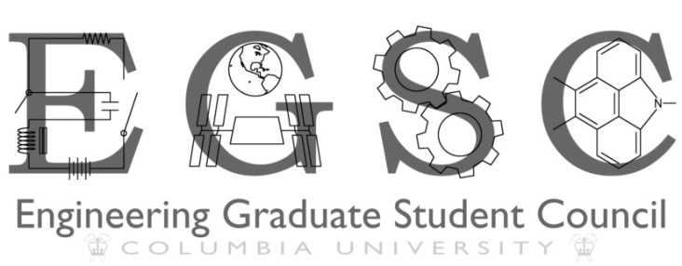

Meeting Agenda November 4, 2011

1. Meeting with Dean Pena-Mora
   1. RFP
      1. RFP explanation
      2. Student help, petition?
   2. SEAS Graduation 2012
      1. SEAS Grad Student Speaker for SEAS Class Day
      2. PhD student inclusion in Class Day
      3. Hooding/ PhD Graduation logistics
   3. Awards
      1. Grad student eligible?
      2. Separate Grad student awards?
   4. Facilities improvements
      1. Carleton Lounge renovation – status updates
      2. Mudd Library Renovation?
      3. Tent Project
      4. Overall Facilities
   5. Fees
      1. Update of current EGSC use of fees
      2. Future of the fee?
   6. Academics
      1. Course evaluation issue in Senate- what is SEAS doing about it?
         1. Availability of evaluations to students
      2. Academic integrity issue
      3. Research Advisor Evaluations
   7. Alumni Interaction
      1. Engineers Connect Feedback
      2. Next Engineers Connect
      3. Spring ’12 events with Alumni
   8. Entrepreneurship
      1. Update on Concentration/ Certificate for Students
      2. Student Entrepreneurship in general
2. Voting on Constitutional amendment
3. Happy Hour/Trivia Night rescheduling